ACTIVITY DIAGRAM HI-CHAT

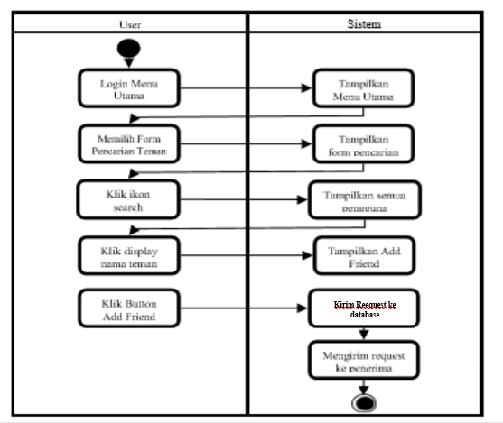

ERD HI-CHAT

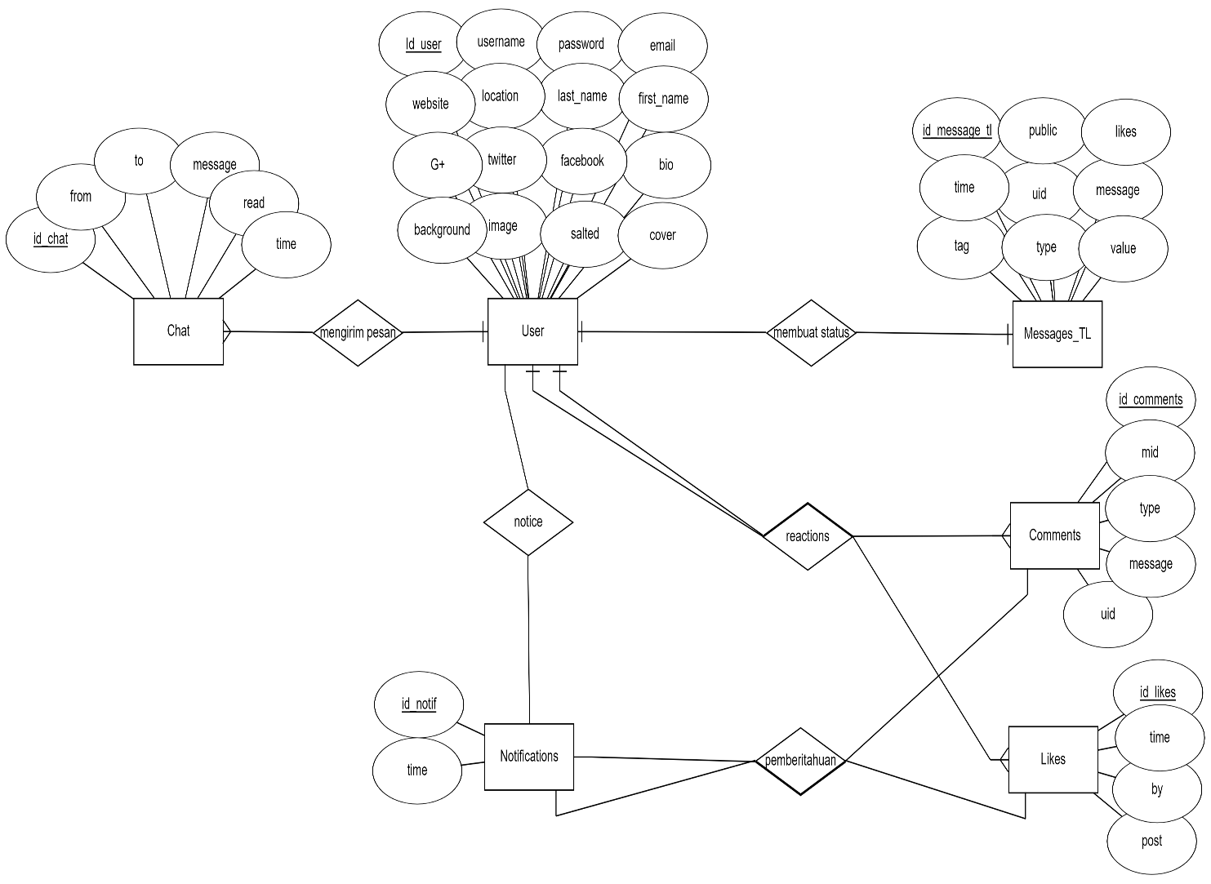

USE CASE HI-CHAT

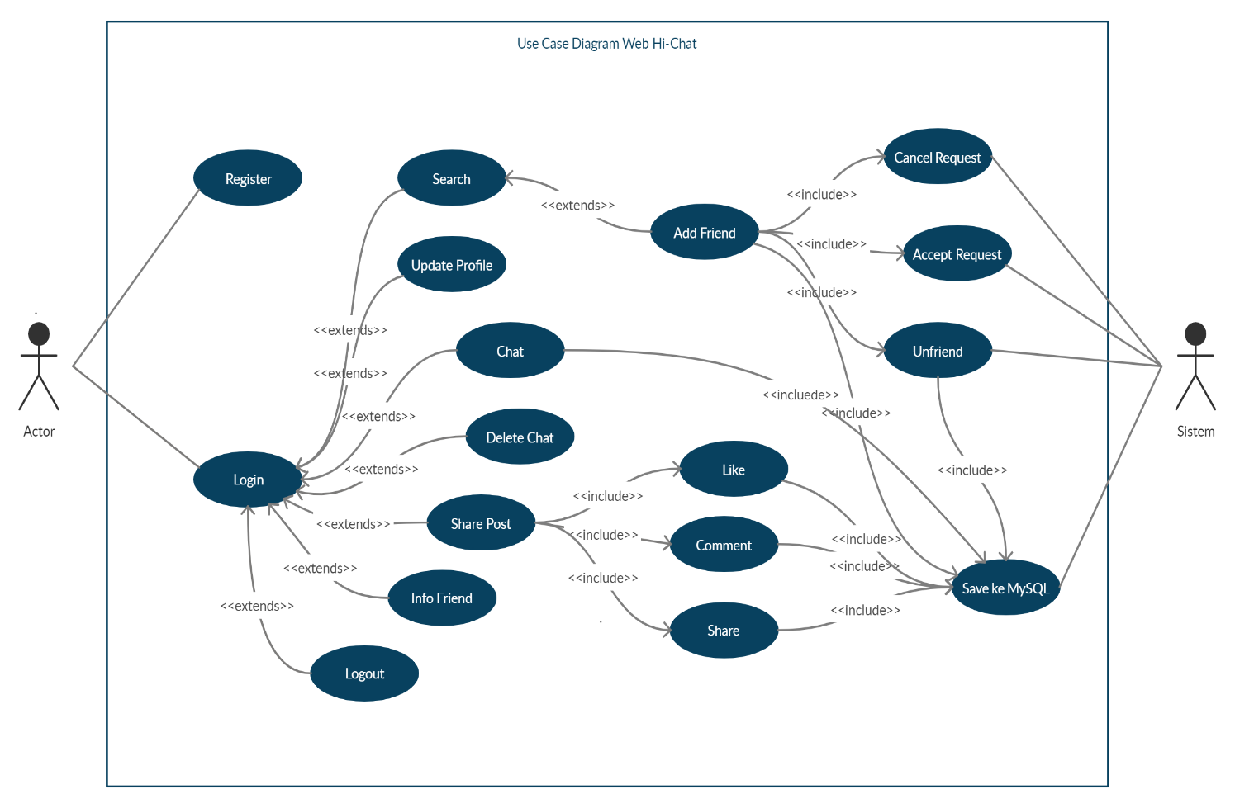

SEQUENCE CHAT WEB HI-CHAT

